9 CUTE SUPERBOWL OUTFIT IDEAS FOR THE ULTIMATE CHILL VIBE



Football season is basically a holiday for our wardrobes. Even if you only care about the halftime show or the snacks, you still need a look that works for the couch and the party. Finding the right balance between cozy and cool is everything for game day. You want to look like you tried without looking like you tried too hard. This year is all about relaxed fits and effortless energy. I gathered 9 Cute Superbowl Outfit Ideas for the Ultimate Chill Vibe so you can stop stressing about what to wear. These looks are perfect for staying comfortable while still looking totally aesthetic in pictures. Check out these styles and get ready to post.

# Jersey and Leggings Superbowl Outfit



Grab an oversized jersey for the perfect base. It looks so good with simple black leggings and some chunky white sneakers. This Superbowl outfit is the easiest way to show team spirit while staying cozy on the sofa. You can tuck the front of the jersey into your waistband to give it a little more shape.

# Puffer Vest Superbowl Outfit

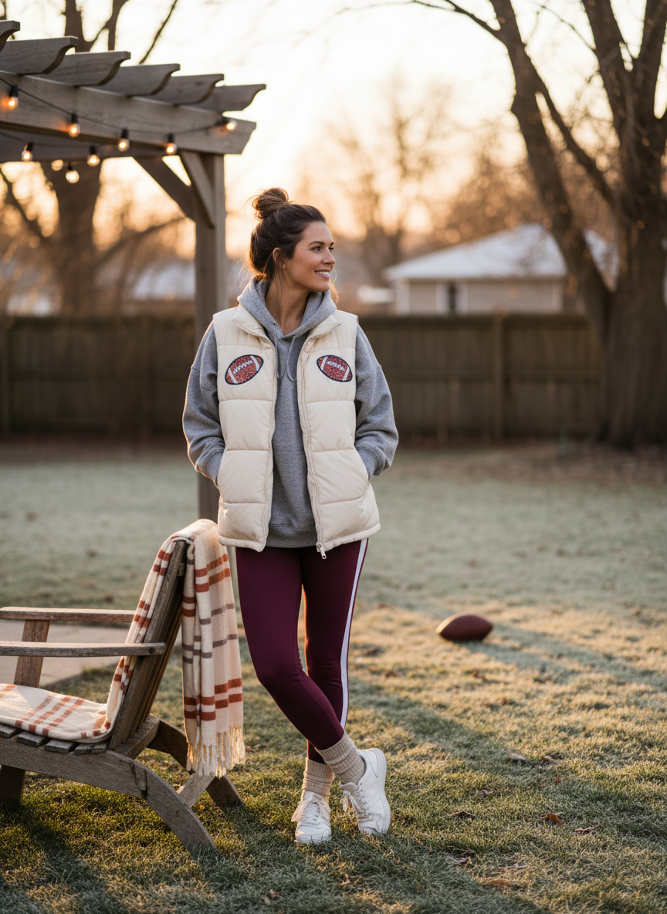

A cropped puffer vest over a plain hoodie is such a move. It adds a layer of style without making you feel too hot inside. This Superbowl outfit works well with your favorite straight leg jeans. It gives off a sporty vibe that is perfect for a backyard party.

# Graphic Tee Superbowl Outfit

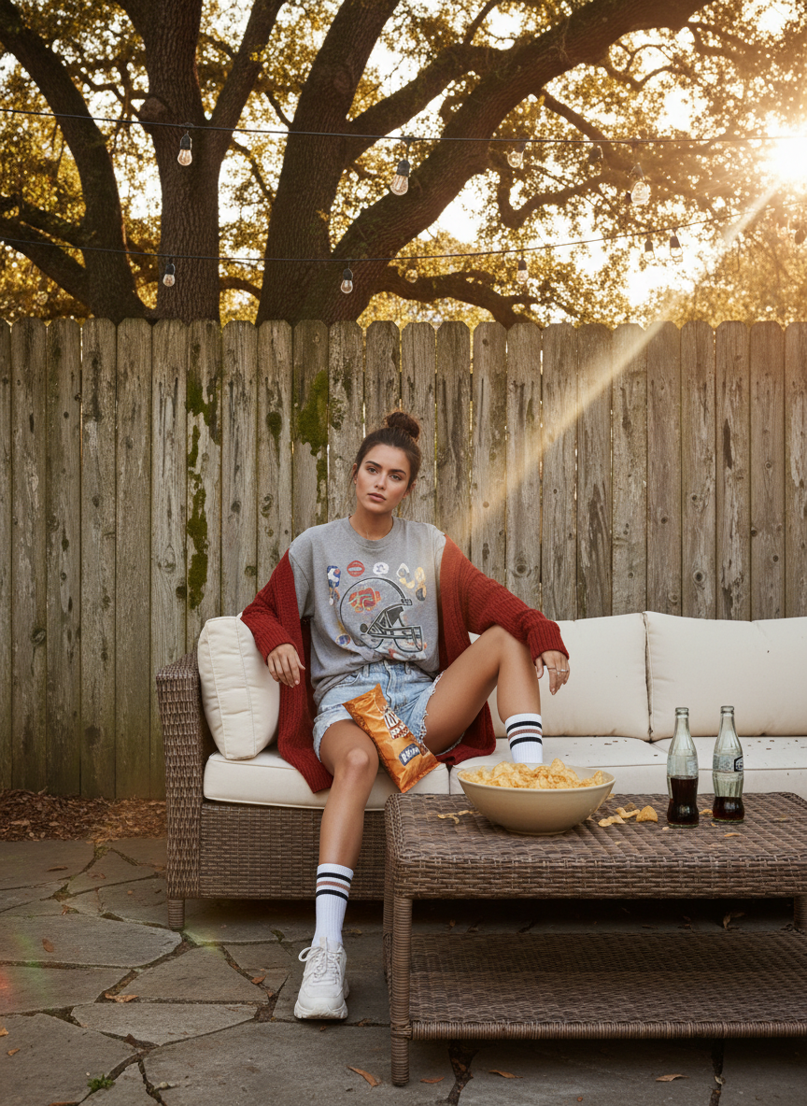

A vintage graphic tee is always a winner. Pair it with some baggy cargo pants for a look that is very trendy right now. This Superbowl outfit is great because it feels very lived in and casual. Add some gold hoop earrings to make the whole thing feel more put together.

# Matching Set Superbowl Outfit

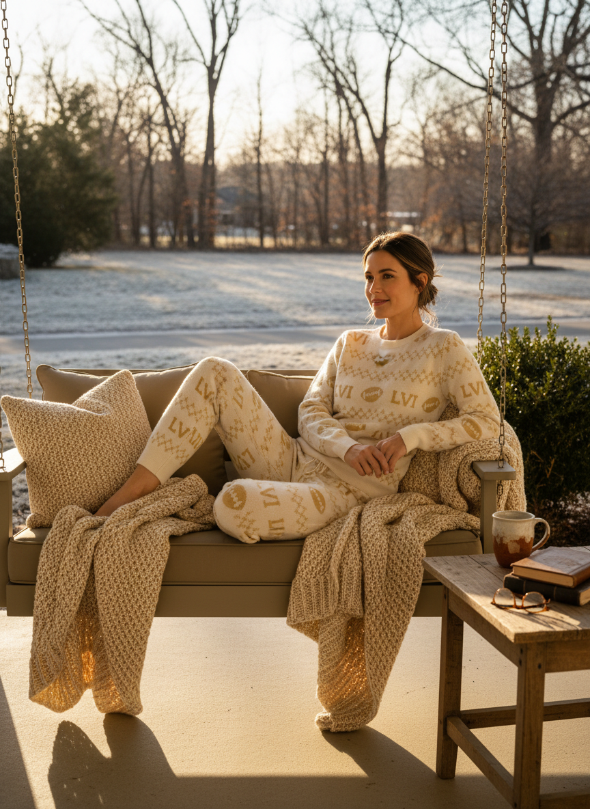

Go for a matching sweatset in a neutral color like cream or grey. It is the ultimate way to stay comfortable during the long game. This Superbowl outfit looks amazing when you add a pair of tall socks over your leggings or joggers. It is basically like wearing pajamas but making it fashion.

# Varsity Jacket Superbowl Outfit

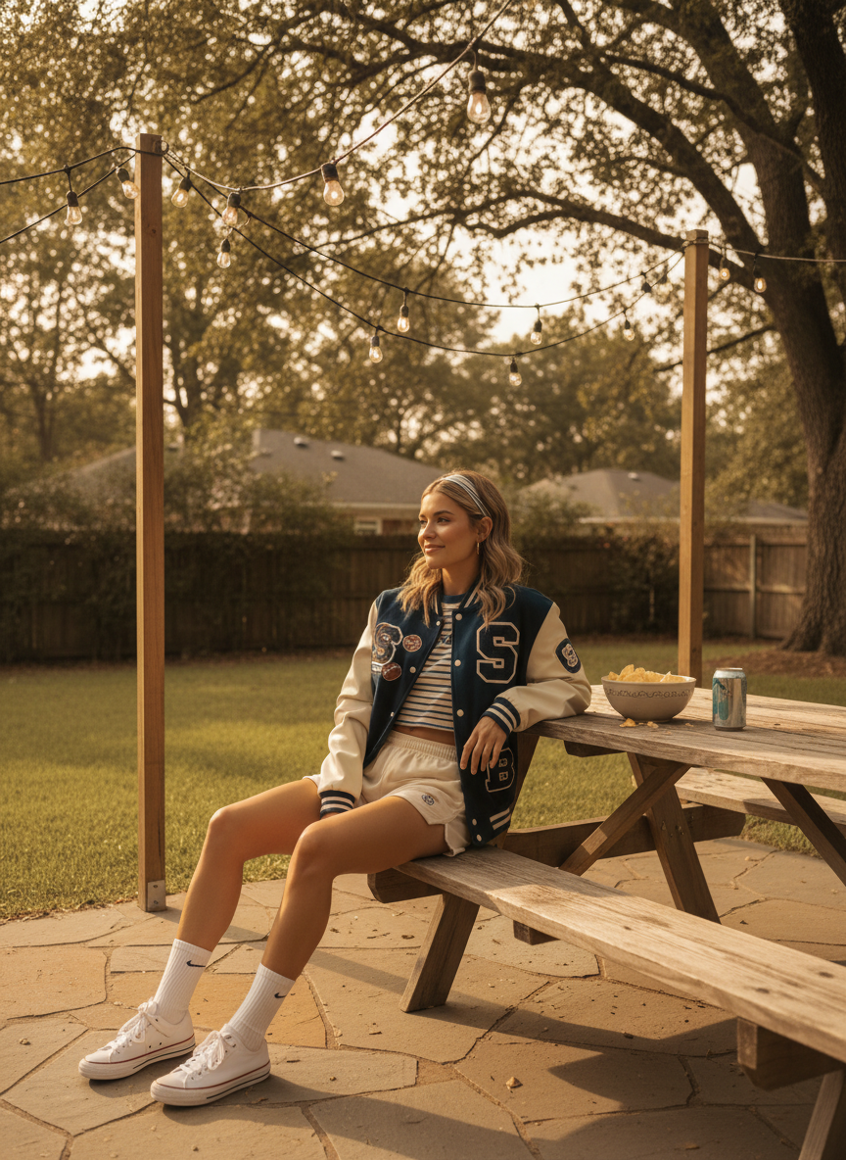

Nothing says game day like a classic varsity jacket. Throw it over a simple white baby tee and some denim shorts. This Superbowl outfit has a retro feel that always looks cool on camera. It is a great way to incorporate team colors without wearing a literal jersey.

# Biker Shorts Superbowl Outfit

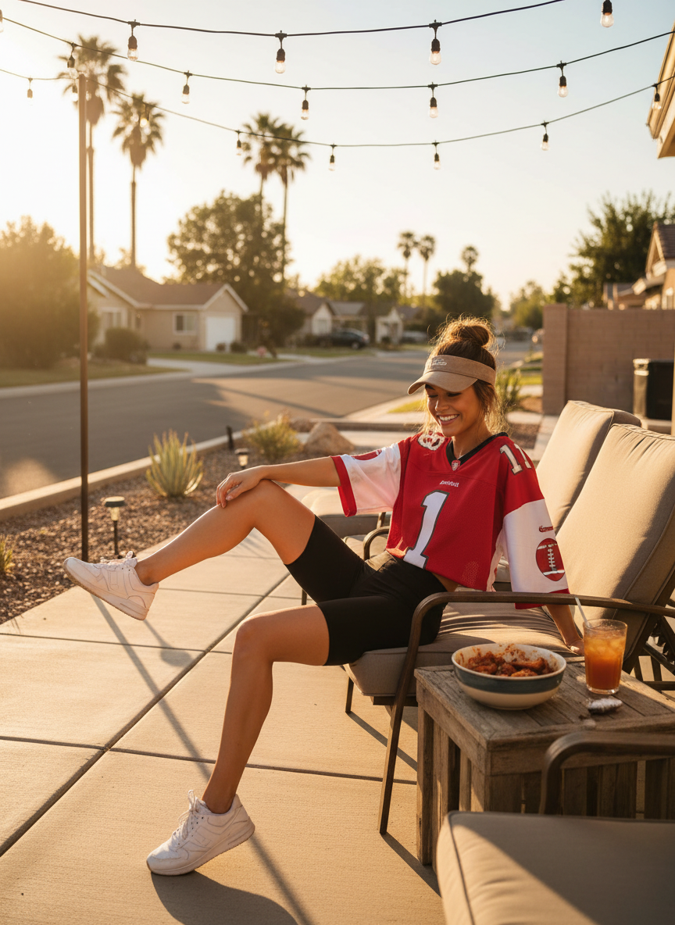

If you live somewhere warmer, biker shorts are the way to go. Combine them with a giant sweatshirt for a balanced silhouette. This Superbowl outfit is very easy to move around in when you are reaching for more wings. Finish the look with some high top sneakers and a messy bun.

# Denim Jacket Superbowl Outfit

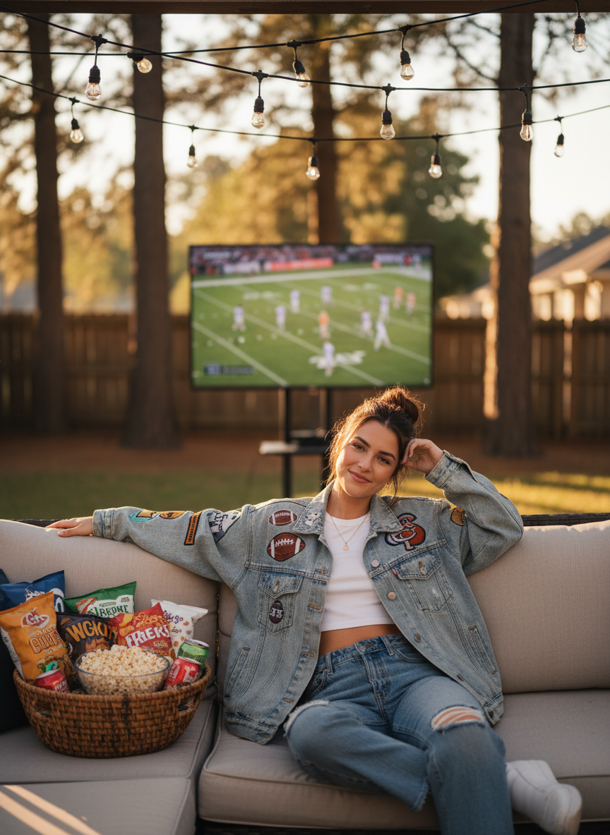

A light wash denim jacket is a closet staple for a reason. Wear it over a fitted tank top and some soft flared leggings. This Superbowl outfit is simple but it never fails to look cute. You can even pin some team buttons on the jacket to customize it.

# Cargo Pants Superbowl Outfit

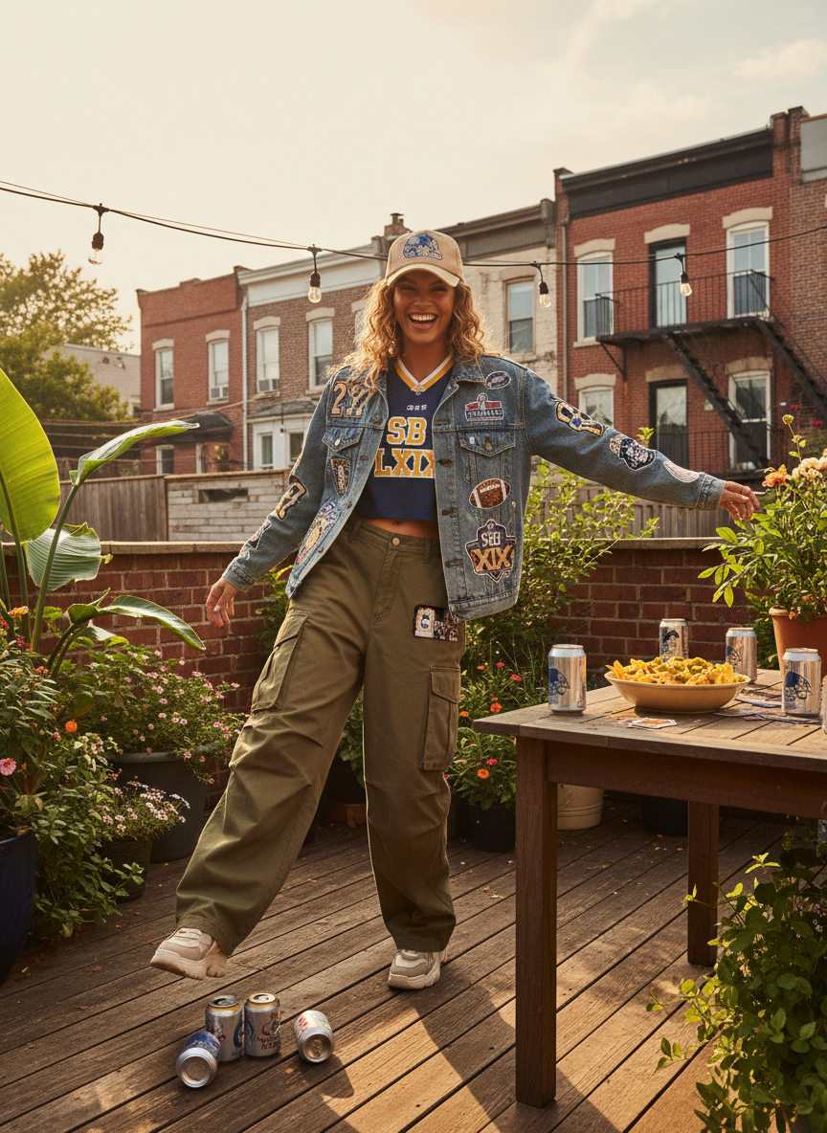

Green or tan cargo pants look so good with a tiny cropped top. It creates a fun contrast between the baggy bottom and the tight top. This Superbowl outfit is perfect if you want to feel a little bit more edgy. The pockets are also super helpful for holding your phone while you eat.

# Beanie and Hoodie Superbowl Outfit



Sometimes you just want to be as warm as possible. A thick hoodie paired with a knit beanie is the coziest choice. This Superbowl outfit is perfect for those low key watch parties at a friend's house. You can stick to monochromatic colors to keep it looking clean and intentional.

# Conclusion

Staying comfy while looking cute is the goal for any big game day. These looks prove you do not have to sacrifice your style just to be relaxed. If you love a jersey or a simple hoodie, there is an option for everyone. Pick your favorite look and get ready to enjoy the game with your friends. Save these ideas to your Pinterest board now.